Internet Programming Lab
Experiments 24–30

Experiment 24: Wanderlust Travels — Online Travel Agency
Design a travel agency website offering flights, hotels, car rentals and vacation packages, with a search engine for deals and destination browsing, and separate User/Admin roles for bookings and content management.

Code
<!DOCTYPE html>
<html><head><meta charset="utf-8"><title>Wanderlust Travels</title>
<style>
body{font-family:Segoe UI,Arial;margin:0;background:#f4f7f9;color:#223}
header{background:#0b5566;color:#fff;padding:22px 40px}
header h1{margin:0;font-size:26px}header p{margin:4px 0 0;opacity:.85}
nav{background:#0e6a80;padding:10px 40px}
nav a{color:#fff;text-decoration:none;margin-right:22px;font-size:14px}
.search{background:#fff;margin:-20px 40px 0;padding:16px 20px;border-radius:8px;box-shadow:0 2px 8px #0002;display:flex;gap:12px}
.search input,.search select{padding:8px;border:1px solid #ccd;border-radius:4px;flex:1}
.search button{background:#e8792c;color:#fff;border:0;padding:9px 18px;border-radius:4px;font-weight:bold}
.cards{display:flex;gap:16px;padding:30px 40px}
.card{background:#fff;border-radius:8px;overflow:hidden;box-shadow:0 1px 4px #0002;flex:1}
.card .img{height:90px;background:linear-gradient(135deg,#3aa1c4,#0b5566)}
.card div.body{padding:12px}
.card h3{margin:0 0 4px;font-size:15px}
.card p{margin:0;font-size:12px;color:#667}
.price{color:#e8792c;font-weight:bold;margin-top:6px}
</style></head>
<body>
<header><h1>Wanderlust Travels</h1><p>Flights • Hotels • Car Rentals • Vacation Packages</p></header>
<nav><a href="#">Home</a><a href="#">Destinations</a><a href="#">Packages</a><a href="#">My Bookings</a><a href="#">Login</a></nav>
<div class="search">
<input placeholder="From"><input placeholder="Destination">
<input type="date"><select><option>1 Traveler</option><option>2 Travelers</option></select>
<button>Search Deals</button>
</div>
<div class="cards">
<div class="card"><div class="img"></div><div class="body"><h3>Bali Getaway</h3><p>5N/6D · Flights + Hotel + Tours</p><div class="price">₹42,999</div></div></div>
<div class="card"><div class="img"></div><div class="body"><h3>Swiss Alps Escape</h3><p>7N/8D · Flights + Hotel + Car</p><div class="price">₹1,29,999</div></div></div>
<div class="card"><div class="img"></div><div class="body"><h3>Kerala Backwaters</h3><p>3N/4D · Houseboat + Stay</p><div class="price">₹18,499</div></div></div>
</div>
</body></html>

Output
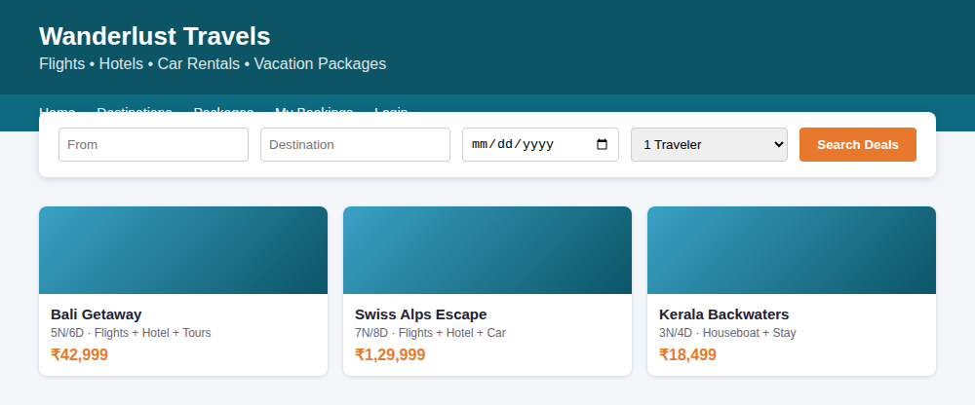

Experiment 25: RoadSaver Assist — Vehicle Breakdown Assistance
Design an on-road vehicle breakdown assistance website that lets users search for licensed mechanics near their location, view distance and ratings, and contact them directly for repair help.

Code
<!DOCTYPE html>
<html><head><meta charset="utf-8"><title>RoadSaver Assist</title>
<style>
body{font-family:Segoe UI,Arial;margin:0;background:#fafafa;color:#222}
header{background:#c0392b;color:#fff;padding:20px 40px}
header h1{margin:0;font-size:24px}
.search{display:flex;gap:10px;padding:18px 40px;background:#fff;box-shadow:0 1px 4px #0002}
.search input{flex:1;padding:9px;border:1px solid #ccc;border-radius:4px}
.search button{background:#c0392b;color:#fff;border:0;padding:9px 20px;border-radius:4px}
.list{padding:20px 40px}
.mech{display:flex;justify-content:space-between;align-items:center;background:#fff;border:1px solid #eee;border-radius:6px;padding:14px 18px;margin-bottom:10px}
.mech .info h3{margin:0 0 4px;font-size:15px}
.mech .info span{font-size:12px;color:#777}
.badge{background:#e8f8ee;color:#1e7e34;font-size:11px;padding:3px 8px;border-radius:10px;margin-left:6px}
.dist{color:#c0392b;font-weight:bold;font-size:13px}
button.call{background:#1e7e34;color:#fff;border:0;padding:6px 14px;border-radius:4px;margin-left:10px}
</style></head>
<body>
<header><h1>🚗 RoadSaver Assist</h1><p style="margin:4px 0 0;font-size:13px">On-Road Vehicle Breakdown Assistance</p></header>
<div class="search"><input placeholder="Enter your location / landmark"><button>Find Mechanics Nearby</button></div>
<div class="list">
<div class="mech"><div class="info"><h3>Ashok Auto Works <span class="badge">Licensed</span></h3><span>★4.6 · Engine, Tyre, Battery</span></div><div><span class="dist">1.2 km away</span><button class="call">Call</button></div></div>
<div class="mech"><div class="info"><h3>Speedy Garage <span class="badge">Licensed</span></h3><span>★4.3 · Towing, AC Repair</span></div><div><span class="dist">2.8 km away</span><button class="call">Call</button></div></div>
<div class="mech"><div class="info"><h3>City Wheels Care <span class="badge">Licensed</span></h3><span>★4.8 · Puncture, Battery</span></div><div><span class="dist">3.5 km away</span><button class="call">Call</button></div></div>
</div>
</body></html>

Output
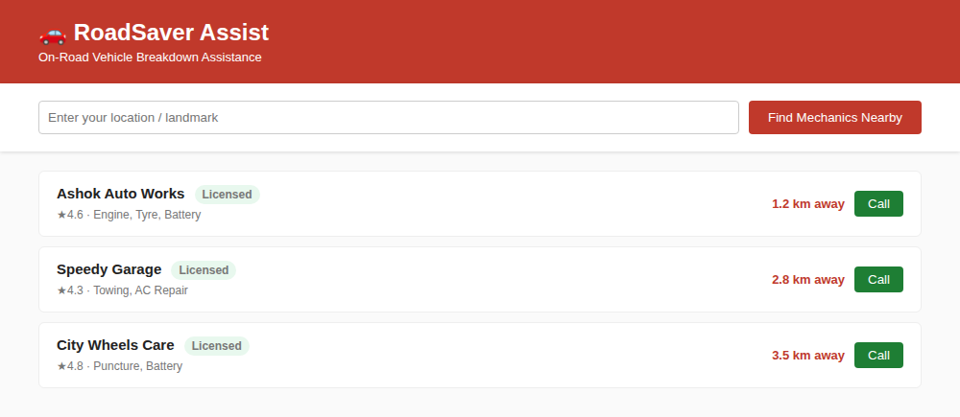

Experiment 26: Traffic Squad — Online FIR & Challan Management
Design a traffic-police web application where police can create an online FIR with vehicle/owner proof, and users can view their challan (fine) records and case status by vehicle number.

Code
<!DOCTYPE html>
<html><head><meta charset="utf-8"><title>Traffic Squad</title>
<style>
body{font-family:Segoe UI,Arial;margin:0;background:#f2f4f7;color:#222}
header{background:#16324f;color:#fff;padding:18px 40px;display:flex;justify-content:space-between;align-items:center}
header h1{margin:0;font-size:22px}
.badge{background:#e63946;padding:4px 10px;border-radius:4px;font-size:12px}
.panel{margin:24px 40px;background:#fff;border-radius:8px;box-shadow:0 1px 4px #0002}
.panel h2{margin:0;padding:14px 18px;border-bottom:1px solid #eee;font-size:16px;background:#f8f9fb}
table{width:100%;border-collapse:collapse;font-size:13px}
th,td{padding:10px 18px;text-align:left;border-bottom:1px solid #f0f0f0}
th{color:#666;font-weight:600}
.paid{color:#1e7e34;font-weight:bold}.pending{color:#c0392b;font-weight:bold}
</style></head>
<body>
<header><h1>🚦 Traffic Squad</h1><span class="badge">Penalty Collection &amp; Management</span></header>
<div class="panel">
<h2>Challan Records — Vehicle No: TN 22 BZ 4521</h2>
<table>
<tr><th>FIR ID</th><th>Violation</th><th>Date</th><th>Fine</th><th>Status</th></tr>
<tr><td>FIR-1042</td><td>Signal Jump</td><td>12-Aug-2026</td><td>₹500</td><td class="pending">Pending</td></tr>
<tr><td>FIR-1039</td><td>No Helmet</td><td>03-Jul-2026</td><td>₹300</td><td class="paid">Paid</td></tr>
<tr><td>FIR-1021</td><td>Overspeeding</td><td>19-May-2026</td><td>₹1000</td><td class="paid">Paid</td></tr>
</table>
</div>
</body></html>

Output
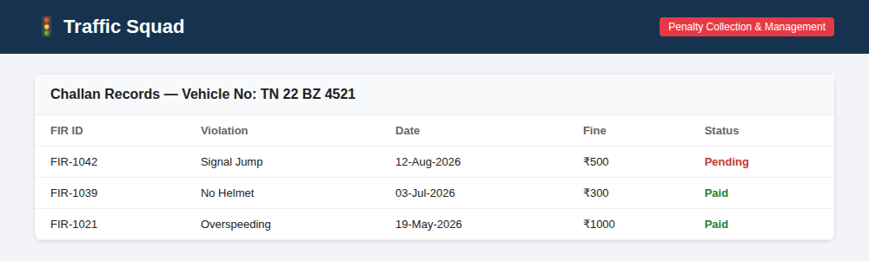

Experiment 27: SmartBus Pass — Student & Route Bus Pass System
Design a bus pass management website where users maintain an eWallet, buy bus e-tickets, apply for or renew student/route passes, and get a QR code for conductor verification.

Code
<!DOCTYPE html>
<html><head><meta charset="utf-8"><title>SmartBus Pass</title>
<style>
body{font-family:Segoe UI,Arial;margin:0;background:#eef3f0;color:#222}
header{background:#2d6a4f;color:#fff;padding:18px 40px}
.wallet{display:flex;gap:16px;padding:20px 40px}
.wcard{flex:1;background:#fff;border-radius:8px;padding:16px;box-shadow:0 1px 4px #0002}
.wcard h3{margin:0;font-size:13px;color:#666}
.wcard .amt{font-size:22px;font-weight:bold;color:#2d6a4f;margin-top:6px}
.actions{display:flex;gap:12px;padding:0 40px 24px}
.actions button{flex:1;padding:14px;border:0;border-radius:6px;background:#fff;box-shadow:0 1px 4px #0002;font-size:13px;font-weight:600;color:#2d6a4f}
.qr{margin:0 40px 30px;background:#fff;border-radius:8px;padding:16px;display:flex;align-items:center;gap:16px;box-shadow:0 1px 4px #0002}
.qrbox{width:70px;height:70px;background:repeating-conic-gradient(#222 0 25%,#fff 0 50%) 0/14px 14px}
</style></head>
<body>
<header><h1 style="margin:0;font-size:22px">🚌 SmartBus Pass</h1><p style="margin:4px 0 0;font-size:13px;opacity:.9">Student &amp; Route Pass Management</p></header>
<div class="wallet">
<div class="wcard"><h3>eWallet Balance</h3><div class="amt">₹340</div></div>
<div class="wcard"><h3>Pass Type</h3><div class="amt">Student</div></div>
<div class="wcard"><h3>Valid Till</h3><div class="amt">31-Mar-2027</div></div>
</div>
<div class="actions">
<button>+ Add Money</button><button>Buy e-Ticket</button><button>Renew Pass</button><button>Apply Route Pass</button>
</div>
<div class="qr"><div class="qrbox"></div><div><b>Your Pass QR Code</b><p style="margin:4px 0 0;font-size:12px;color:#666">Show this at the conductor scan point for verification</p></div></div>
</body></html>

Output
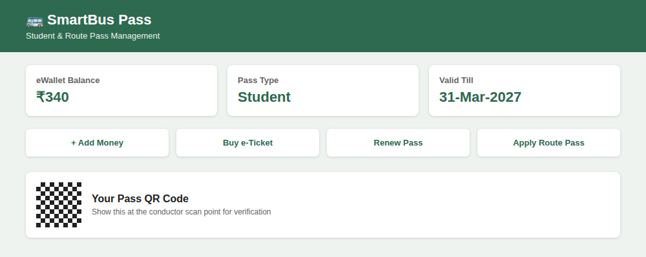

Experiment 28: ArtistryHub — Artist Portfolio Website
Design a portfolio website for artist Emily Harris featuring a homepage banner, navigation to About/Portfolio/Blog/Store/Contact, an artwork gallery, and a biography section.

Code
<!DOCTYPE html>
<html><head><meta charset="utf-8"><title>ArtistryHub</title>
<style>
body{font-family:Georgia,serif;margin:0;background:#fff;color:#2b2b2b}
.banner{height:180px;background:linear-gradient(120deg,#7b2ff7,#f107a3);display:flex;align-items:center;justify-content:center;color:#fff}
.banner h1{font-size:34px;margin:0}.banner p{font-family:Segoe UI,sans-serif;font-size:13px;letter-spacing:2px}
nav{display:flex;justify-content:center;gap:26px;padding:12px;background:#1c1c1c}
nav a{color:#eee;text-decoration:none;font-family:Segoe UI,sans-serif;font-size:13px}
.gallery{display:flex;gap:10px;padding:24px 40px}
.art{flex:1;height:120px;border-radius:6px}
.a1{background:#ffb703}.a2{background:#219ebc}.a3{background:#fb8500}.a4{background:#8ecae6}
.bio{padding:20px 40px;font-family:Segoe UI,sans-serif}
.bio h2{font-family:Georgia,serif}
.bio p{font-size:13px;line-height:1.6;color:#555}
</style></head>
<body>
<div class="banner"><div><h1>Emily Harris</h1><p>C O N T E M P O R A R Y &nbsp; A R T I S T</p></div></div>
<nav><a href="#">Home</a><a href="#">About</a><a href="#">Portfolio</a><a href="#">Blog</a><a href="#">Store</a><a href="#">Contact</a></nav>
<div class="gallery"><div class="art a1"></div><div class="art a2"></div><div class="art a3"></div><div class="art a4"></div></div>
<div class="bio"><h2>About the Artist</h2><p>Emily Harris is a contemporary painter known for vivid color-field works exploring memory and landscape. Her pieces have been exhibited across galleries worldwide, and this space celebrates her artistic journey.</p></div>
</body></html>

Output
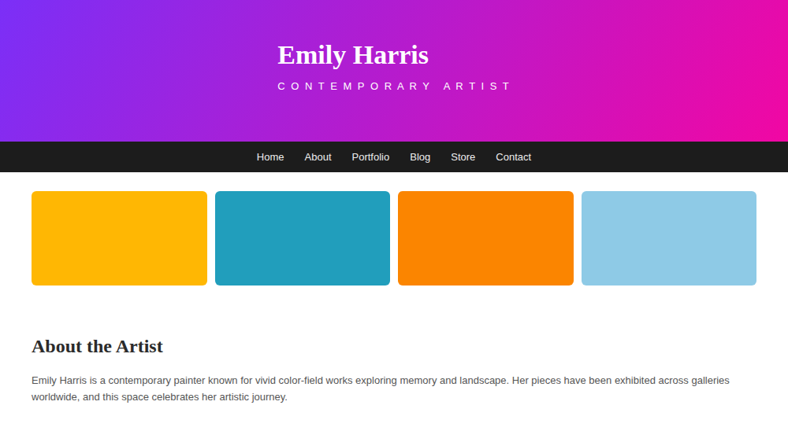

Experiment 29: TechConnect Summit — Event Landing Page
Design a simple, sectioned event page with a header listing speakers with links, the venue and schedule, a section describing the event's purpose and target audience, and a registration button.

Code
<!DOCTYPE html>
<html><head><meta charset="utf-8"><title>TechConnect Summit</title>
<style>
body{font-family:Segoe UI,Arial;margin:0;background:#0f172a;color:#e2e8f0}
header{padding:26px 40px;text-align:center;background:#111827}
header h1{margin:0;font-size:28px;color:#38bdf8}
header p{font-size:13px;color:#94a3b8;margin:6px 0 0}
.speakers{display:flex;gap:16px;justify-content:center;padding:24px 40px}
.sp{text-align:center;width:110px}
.sp .av{width:64px;height:64px;border-radius:50%;background:#38bdf8;margin:0 auto 8px}
.sp h4{margin:0;font-size:13px}.sp span{font-size:11px;color:#94a3b8}
.info{display:flex;gap:16px;padding:0 40px 24px}
.box{flex:1;background:#1e293b;border-radius:8px;padding:14px}
.box h3{margin:0 0 6px;font-size:14px;color:#38bdf8}
.box p{margin:0;font-size:12px;color:#cbd5e1}
.reg{text-align:center;padding-bottom:30px}
.reg button{background:#38bdf8;color:#0f172a;border:0;padding:12px 30px;border-radius:6px;font-weight:bold}
</style></head>
<body>
<header><h1>TechConnect Summit 2026</h1><p>📍 Chennai Convention Centre &nbsp;|&nbsp; 🗓 12 Oct 2026, 9:00 AM</p></header>
<div class="speakers">
<div class="sp"><div class="av"></div><h4>Dr. R. Iyer</h4><span>AI Research</span></div>
<div class="sp"><div class="av"></div><h4>S. Kapoor</h4><span>Cloud Systems</span></div>
<div class="sp"><div class="av"></div><h4>M. Fernandes</h4><span>Cybersecurity</span></div>
</div>
<div class="info">
<div class="box"><h3>Purpose</h3><p>A gathering for developers, students and researchers to explore emerging technology trends.</p></div>
<div class="box"><h3>Audience</h3><p>CS students, working professionals and startup founders interested in tech innovation.</p></div>
<div class="box"><h3>Schedule</h3><p>9:00 Keynote · 11:00 Workshops · 2:00 Panel Discussion · 4:00 Networking</p></div>
</div>
<div class="reg"><button>Register Now</button></div>
</body></html>

Output
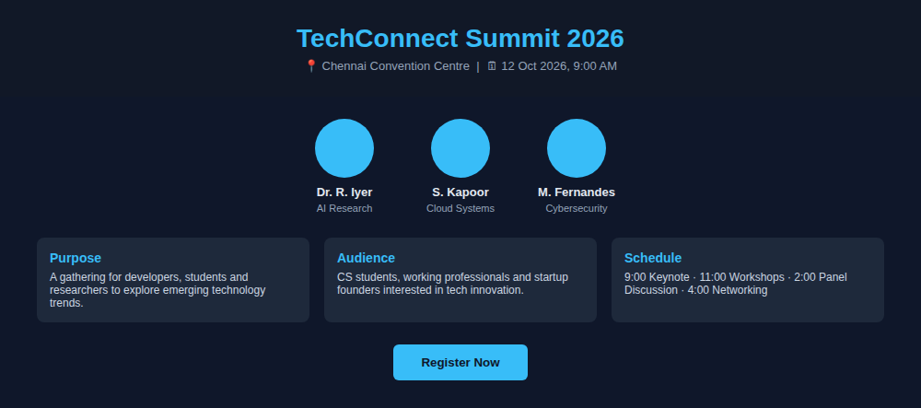

Experiment 30: IJSSE — Scopus-Indexed Journal Website
Design a journal publishing website for IJSSE with an About Journal section, print/online ISSN details, and dedicated menus for Authors, Reviewers and Editors covering submission and review workflows.

Code
<!DOCTYPE html>
<html><head><meta charset="utf-8"><title>IJSSE</title>
<style>
body{font-family:Segoe UI,Arial;margin:0;background:#fff;color:#222}
header{background:#7a1f2b;color:#fff;padding:18px 40px}
header h1{margin:0;font-size:20px}
header p{margin:4px 0 0;font-size:12px;opacity:.9}
nav{background:#5c1620;display:flex}
nav a{color:#fff;text-decoration:none;font-size:12px;padding:12px 16px}
.about{padding:20px 40px;font-size:13px;color:#444;line-height:1.6}
.issn{display:flex;gap:20px;padding:0 40px 20px}
.issn div{background:#f7ebed;border-radius:6px;padding:10px 16px;font-size:12px}
.grid{display:flex;gap:16px;padding:0 40px 30px}
.g{flex:1;background:#faf5f6;border:1px solid #eee;border-radius:8px;padding:14px}
.g h3{margin:0 0 6px;font-size:14px;color:#7a1f2b}
.g p{margin:0;font-size:12px;color:#666}
</style></head>
<body>
<header><h1>International Journal of Scientific and Social Excellence</h1><p>Scopus-Indexed Journal Publisher</p></header>
<nav><a href="#">Home</a><a href="#">About Journal</a><a href="#">For Authors</a><a href="#">For Reviewers</a><a href="#">For Editors</a><a href="#">Articles</a><a href="#">Contact</a></nav>
<div class="about">IJSSE publishes high-quality peer-reviewed research across scientific and social disciplines, supporting a transparent and streamlined submission-to-publication workflow.</div>
<div class="issn"><div><b>Print ISSN:</b> 2395-1443</div><div><b>Online ISSN:</b> 2395-1451</div></div>
<div class="grid">
<div class="g"><h3>For Authors</h3><p>Submit manuscripts, track status, view guidelines & templates.</p></div>
<div class="g"><h3>For Reviewers</h3><p>Access assigned articles and submit review reports.</p></div>
<div class="g"><h3>For Editors</h3><p>Manage submissions and coordinate peer review workflow.</p></div>
</div>
</body></html>

Output
